Name of Student: HARPAL BIDAWAT | PRN:25070122080
Semester: III | Year : AY 2026-27
Subject: Programming with Java
ASSIGNMENT No : 20
TITLE : JDBC INSERT, UPDATE, and DELETE Operations
Problem Statement
Develop a Java application to establish connectivity with a database and perform INSERT, UPDATE, and DELETE operations.
Learning Objectives
To perform database modification operations using JDBC.

Programme
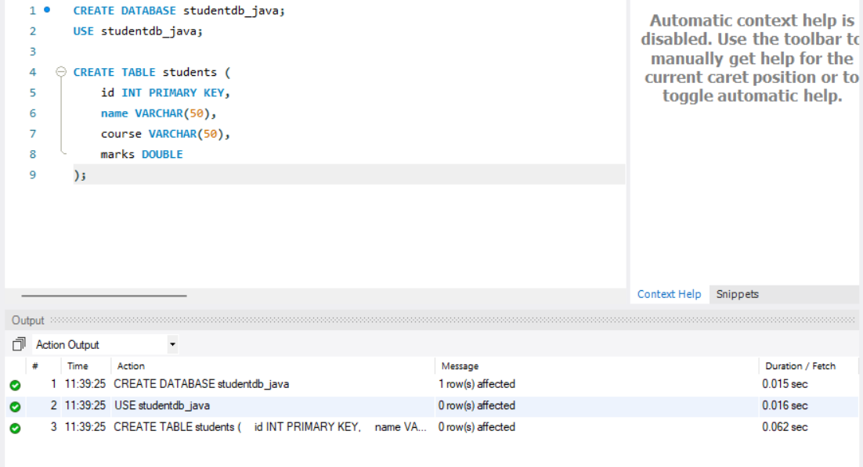
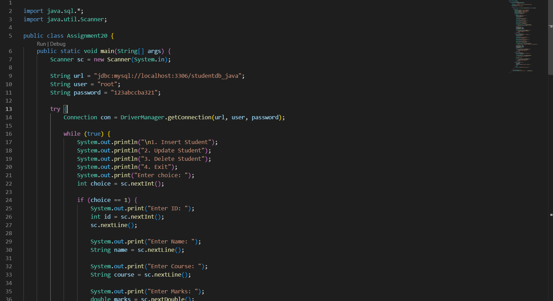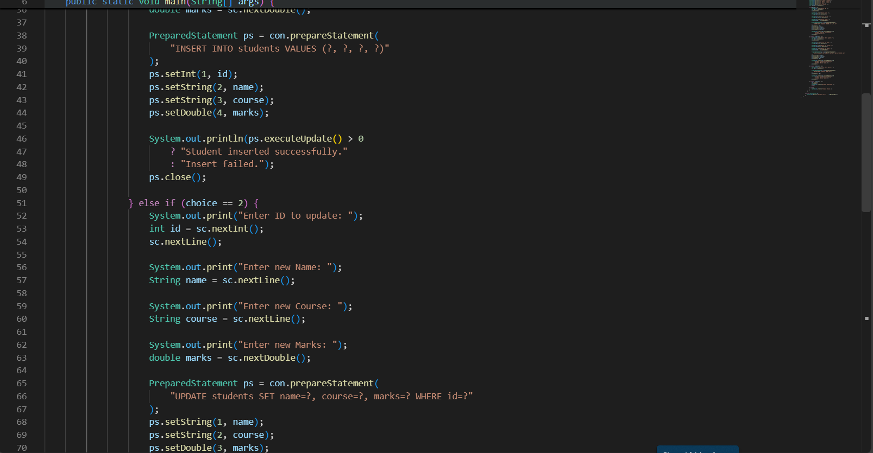
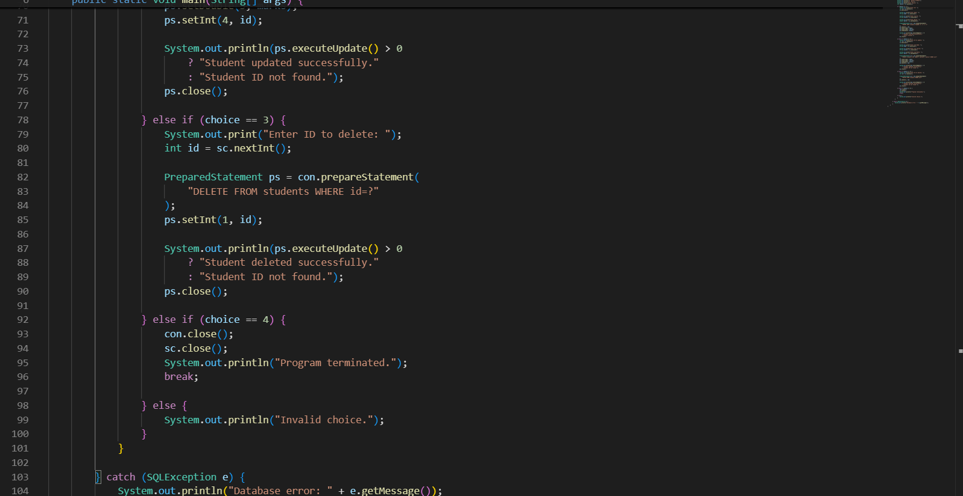
Output
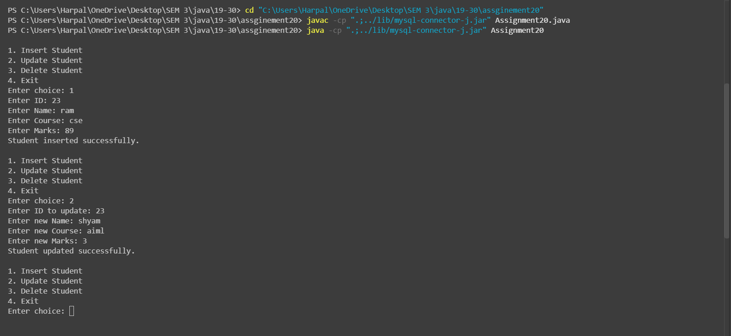
Conclusion
Thus, a Java application was successfully connected to a MySQL database using JDBC. INSERT, UPDATE, and DELETE operations were performed successfully using SQL queries and PreparedStatement.

